**26th January 2016**

**Yokohama Tire Corporation Earns Platinum Supplier Award from Caterpillar for the Fourth Consecutive Year**

SANTA ANA, CA – For the fourth straight year, Yokohama Tire Corporation (YTC) has earned Caterpillar’s premier supplier award: the Platinum Level Recertification in its Supplier Quality Excellence Process (SQEP). The award went to YOKOHAMA’s off-the-road (OTR) factory in Onomichi, Japan.

According to Caterpillar, its SQEP recognizes suppliers like YOKOHAMA that have exhibited excellent process control, shown a desire for ongoing continuous improvement and have provided quality products to Caterpillar.

“We’re truly honoured to receive the Platinum Level Recertification for 2015,” said Andrew Zeisser, YTC director, OE Sales. “Earning an award like this from a world-class OEM like Caterpillar for the fourth consecutive year is a tribute to YOKOHAMA’s global commitment to deliver best-in-class quality products and service.”

YOKOHAMA’s Onomichi plant produces OE and replacement OTR tires for a wide range of off-the-road equipment.

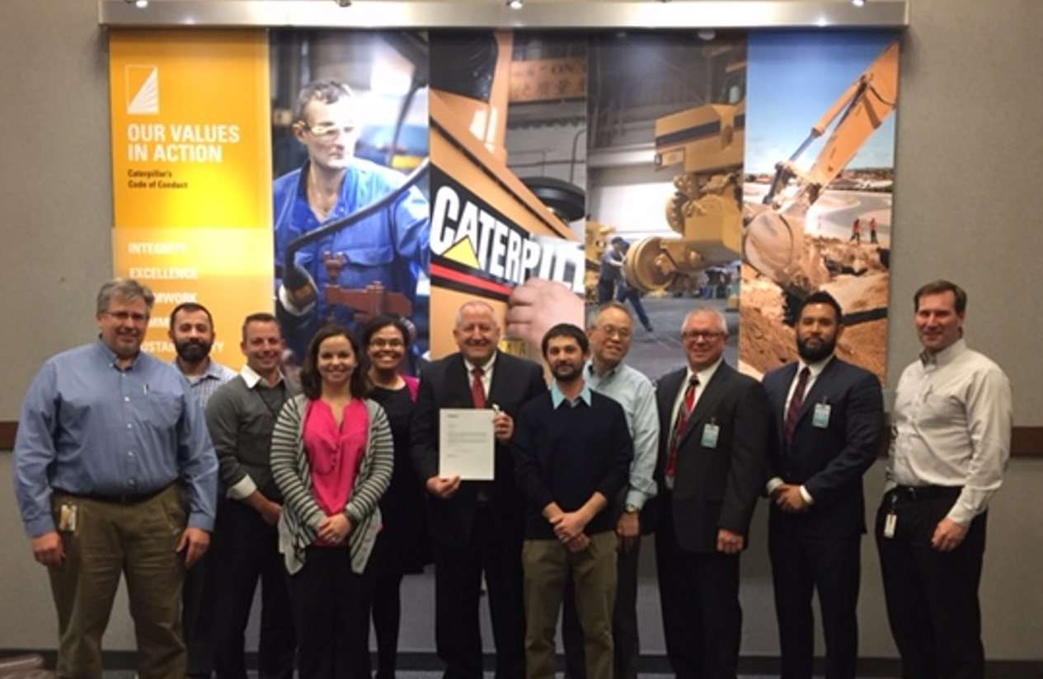

*YOKOHAMA Cat SQEP Award*